Lesson 03 Demo 07

Managing File Share

Objective: To create a file share and upload files

Tools Required: None

Prerequisites: None

Steps to be followed:
- Create a standard file share
- Create a premium file share

Step 1: Create a standard file share

  - Create a storage account

  - Go to the Azure Portal and select + Create a resource

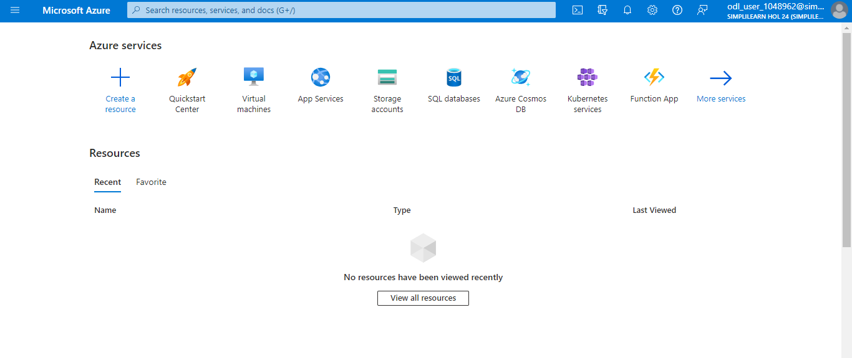

  - Search and select Storage accounts

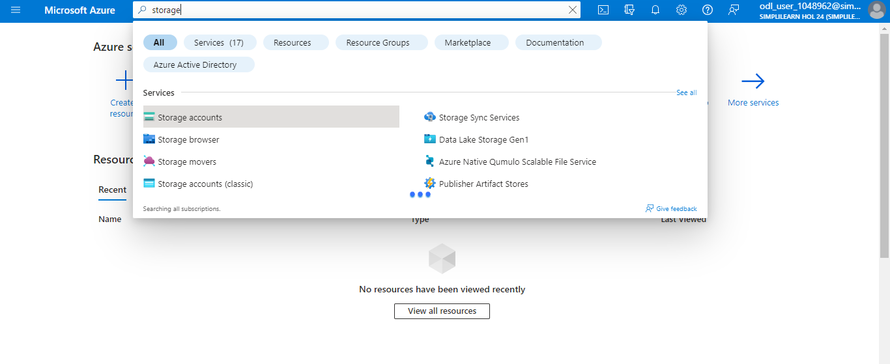

  - Click on Create storage account

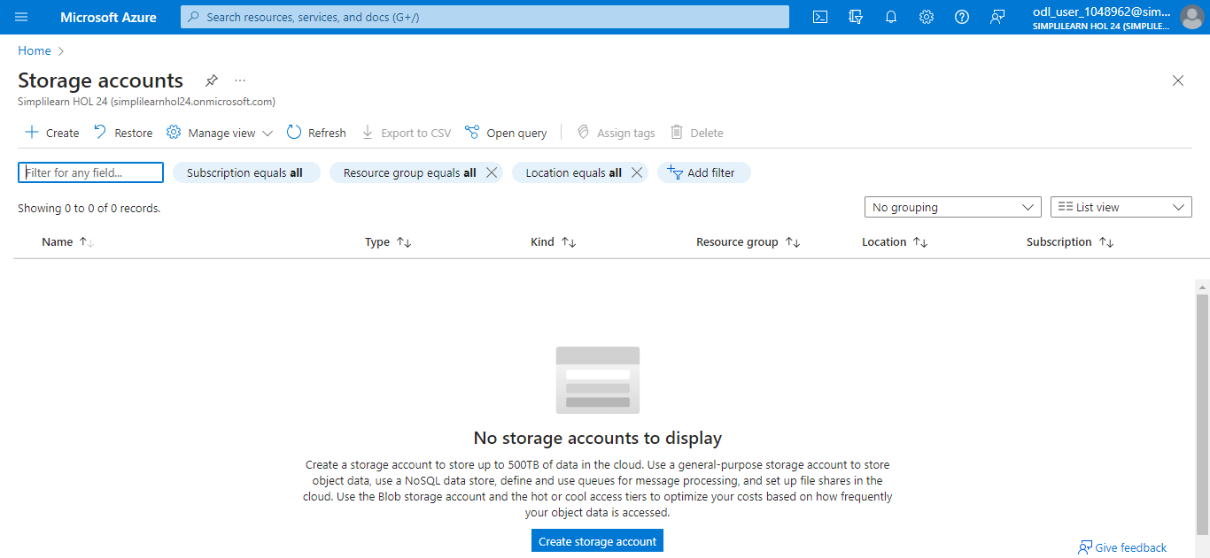

  - Enter a storage account name. Ensure the Performance radio button is set to Standard, and then click on Review

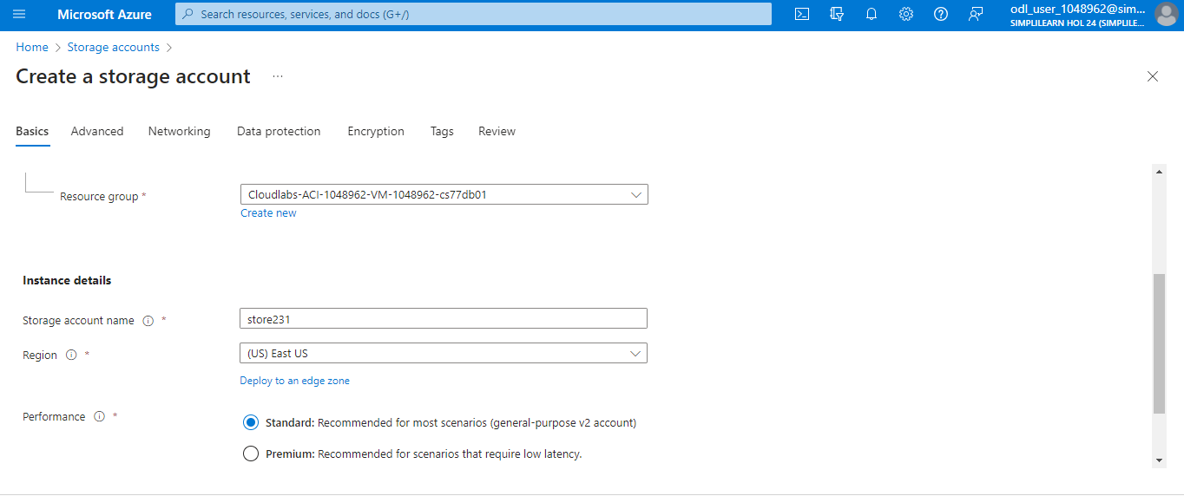

  - Click on Create

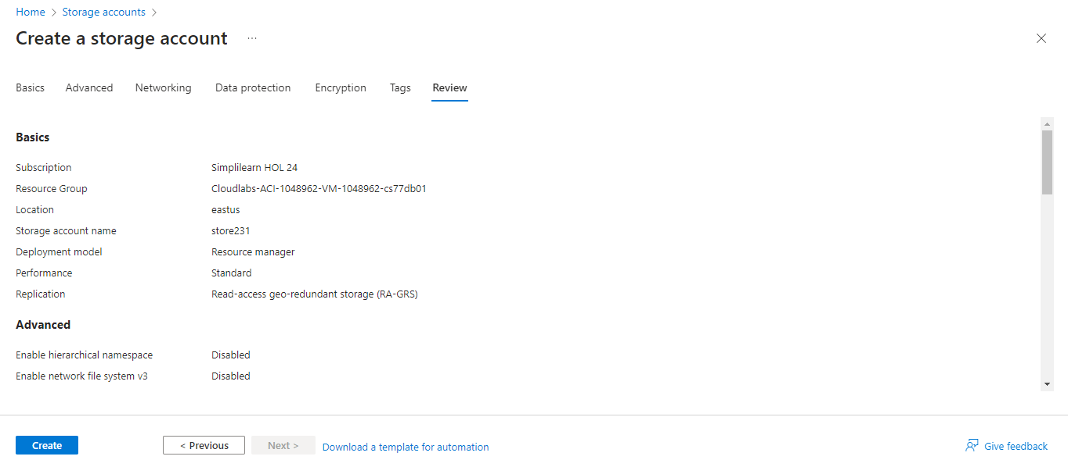

The following screenshot will appear:

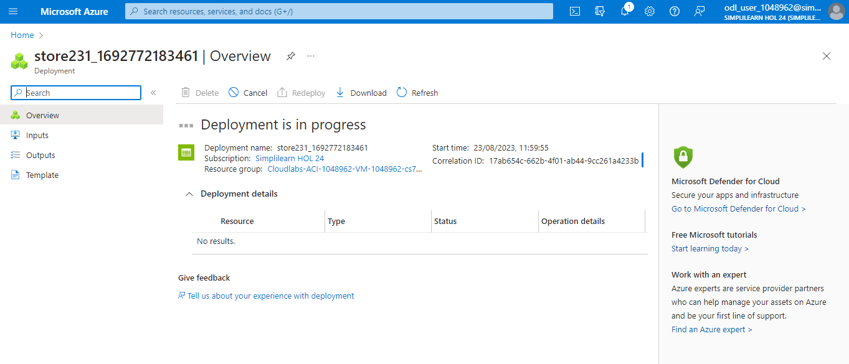

  - Access the storage account and click on File shares, and then click on + File share

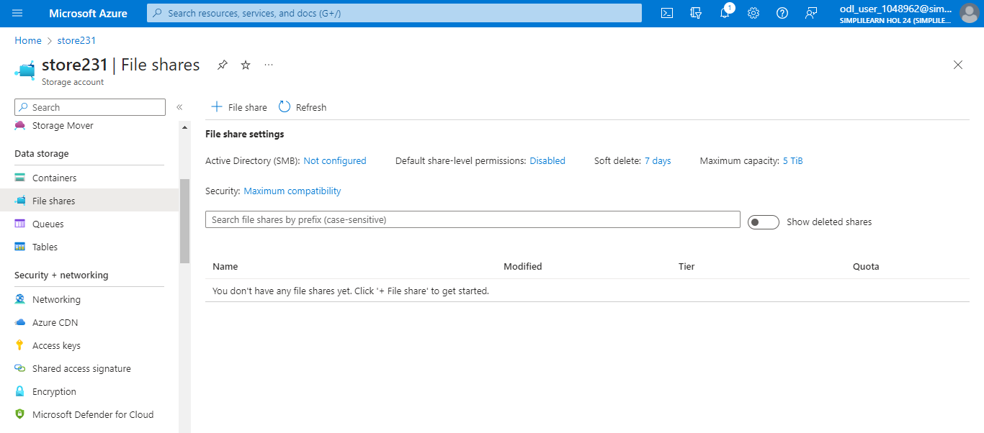

  - Enter a Name and a Tier for the new file share and click on Review + create

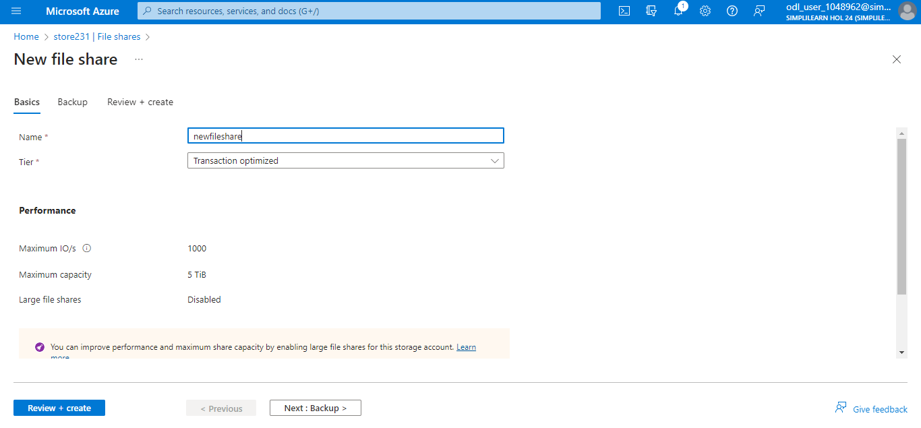

  - Click on Create

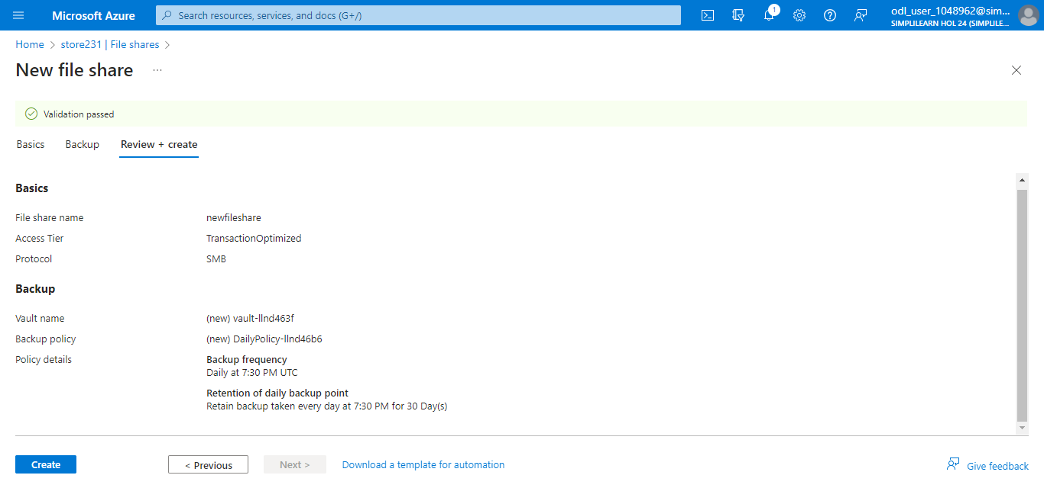

The following screenshot will appear:

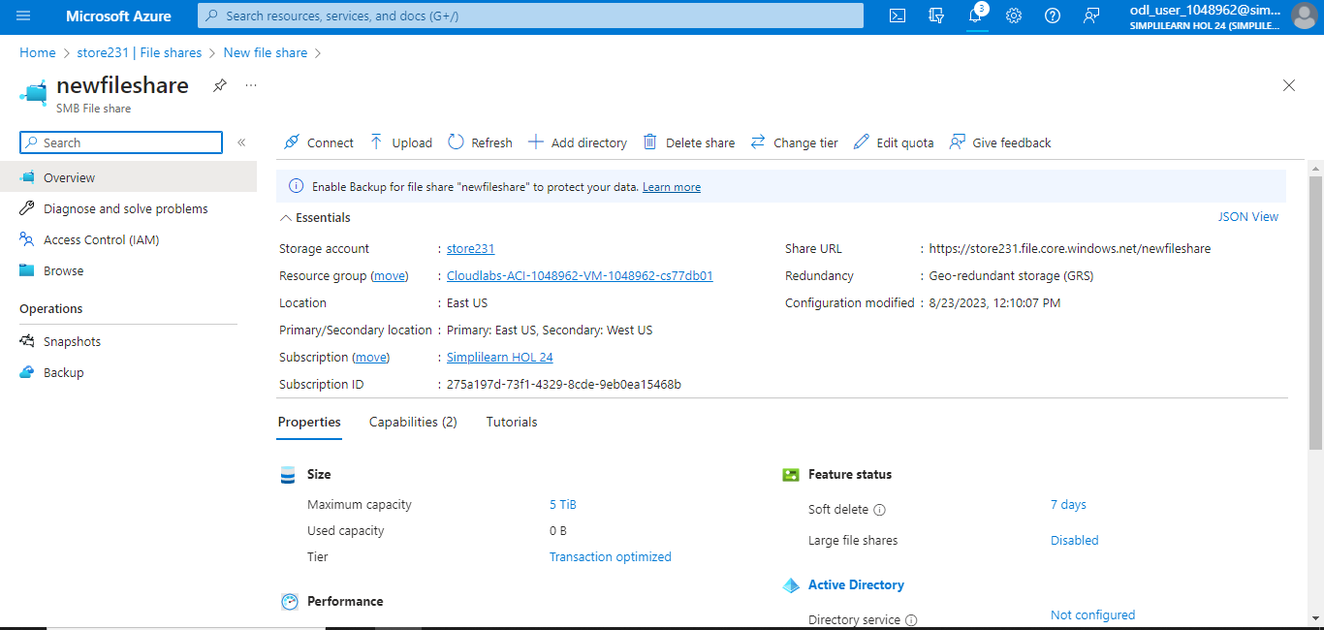

  - Once file share is created, click on the file share name to access it

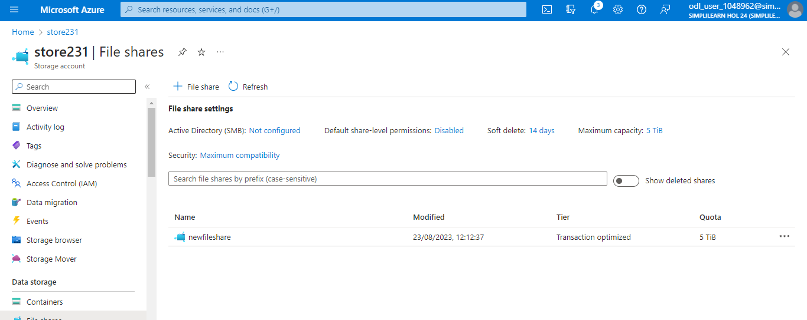

  - After the file share is created, click on Upload

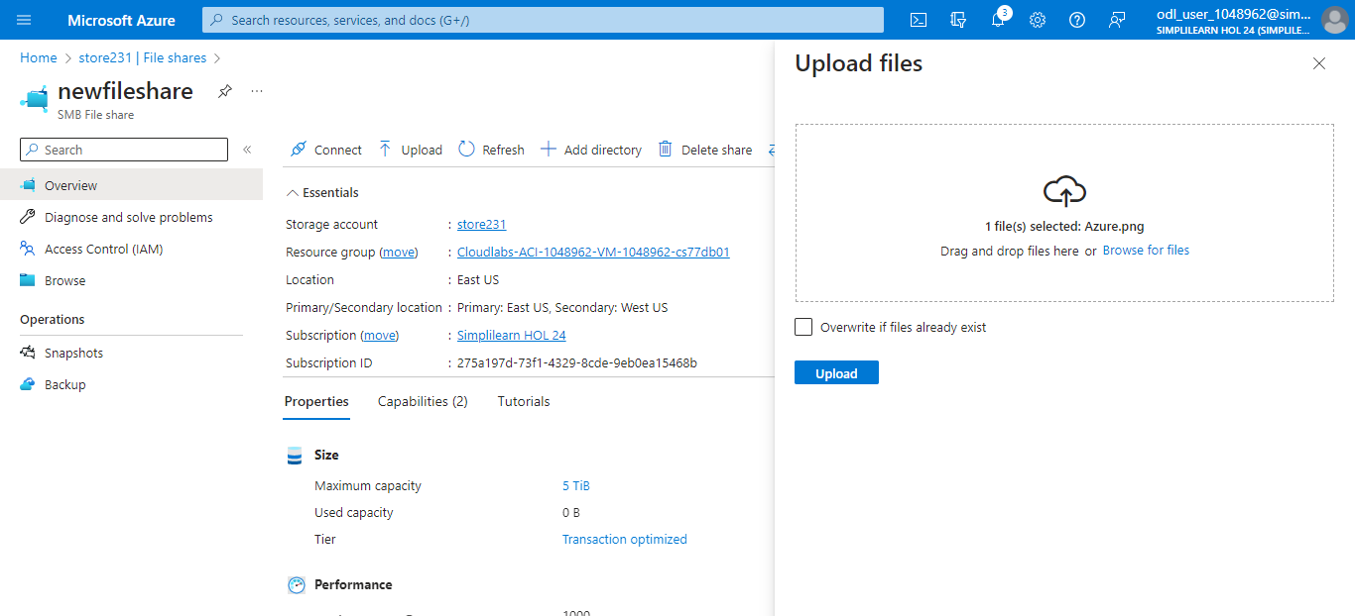

Step 2: Create a premium file share

2.1 Create a storage account

2.2 Go to the Azure Portal and select + Create a resource

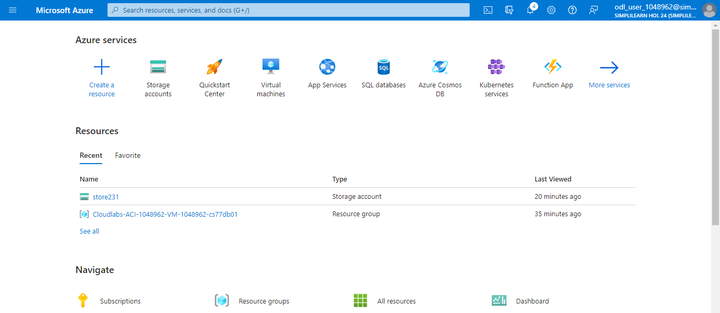

  - Search for Storage accounts and select it

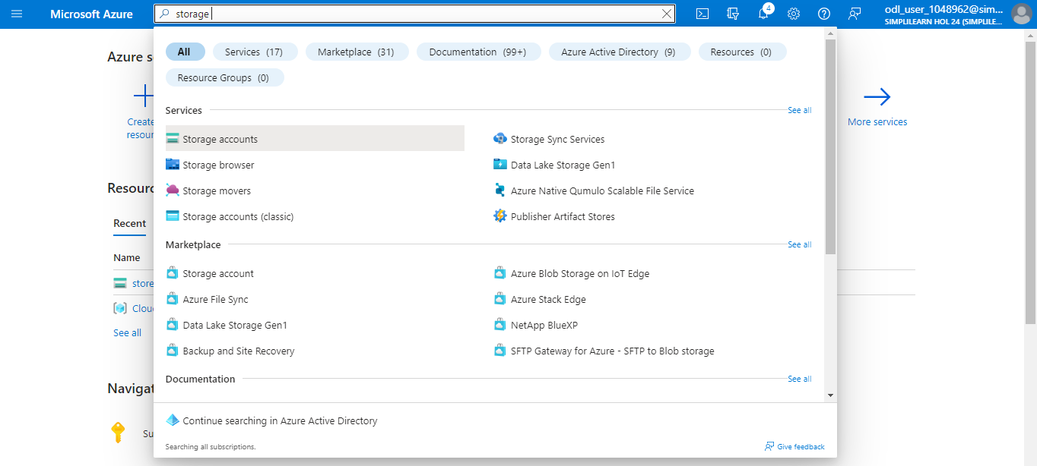

  - Click on + Create

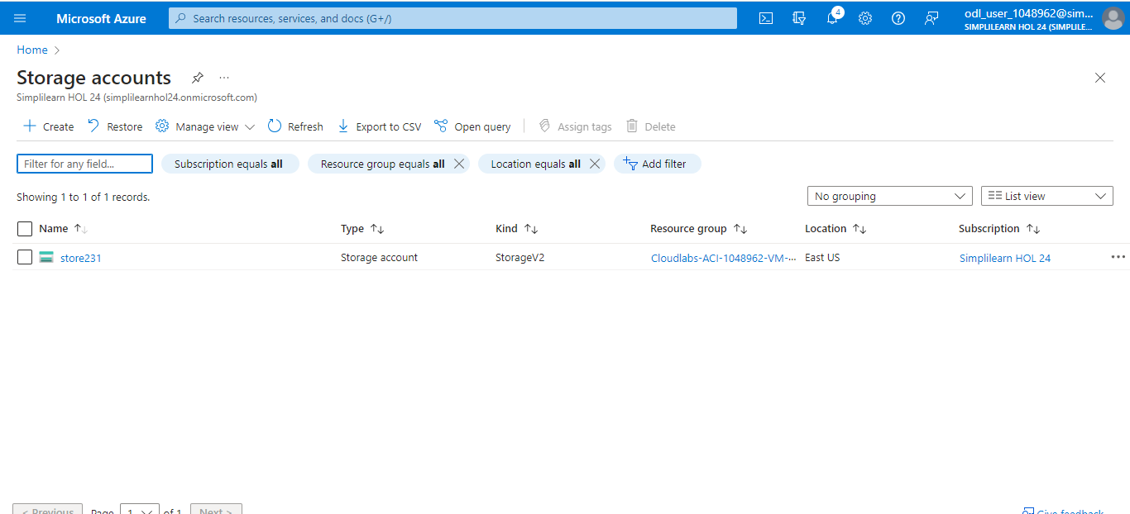

  - Ensure the Performance radio button is set to Premium and File shares is selected in
the Premium account type drop-down list, then click on Review

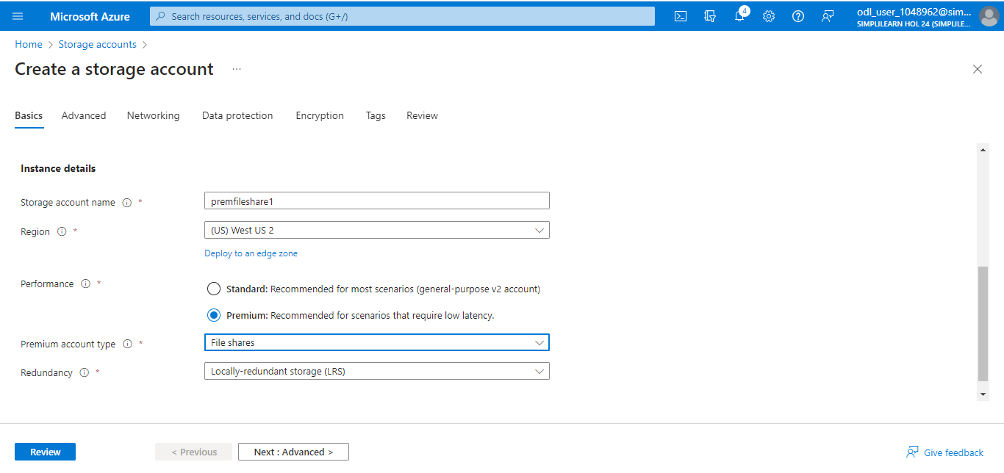

2.6 Click Create

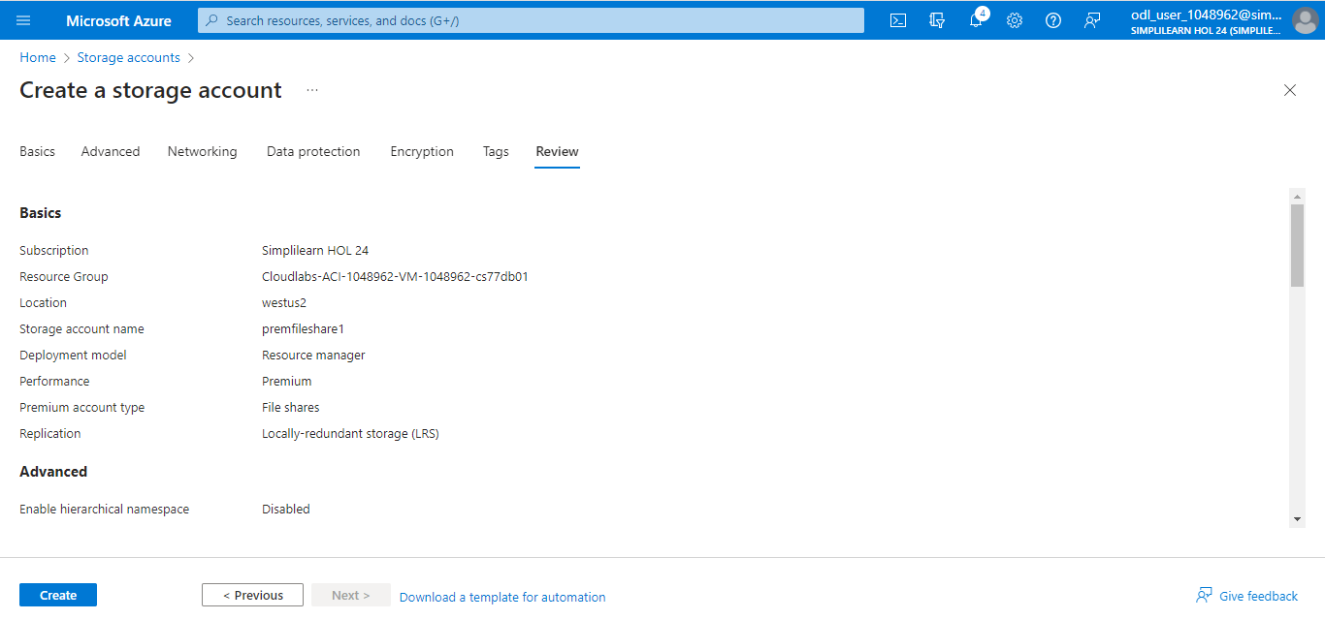

The storage account is created as shown:

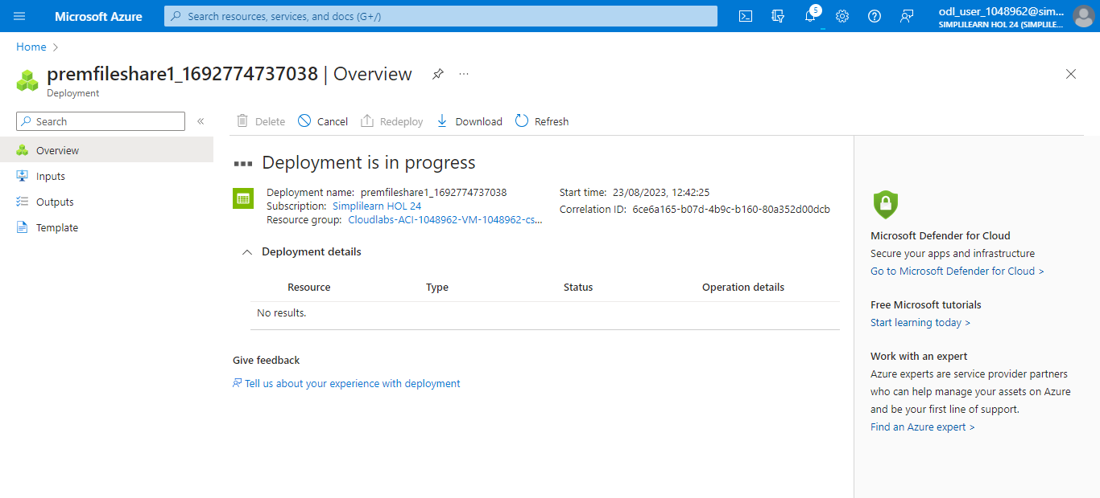

2.7 Access the storage account, click on File shares, and select + File share

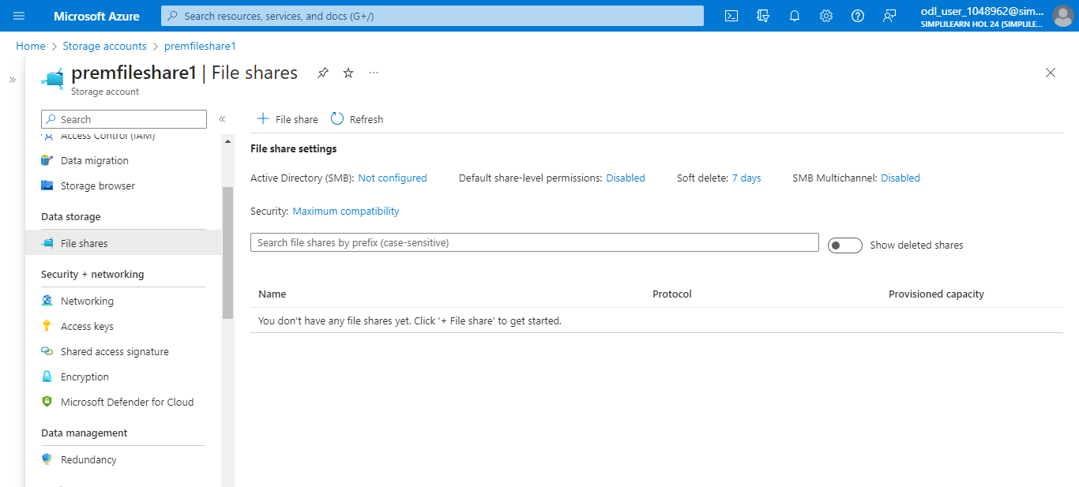

2.8 Give the new file share a Name and a Provisioned capacity

2.9 Click on Review + create

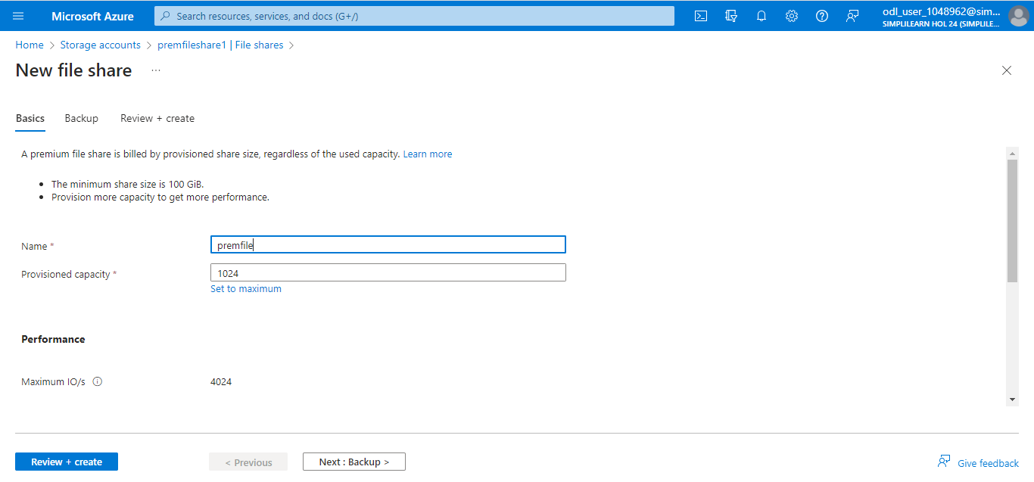

2.10 Click on Create

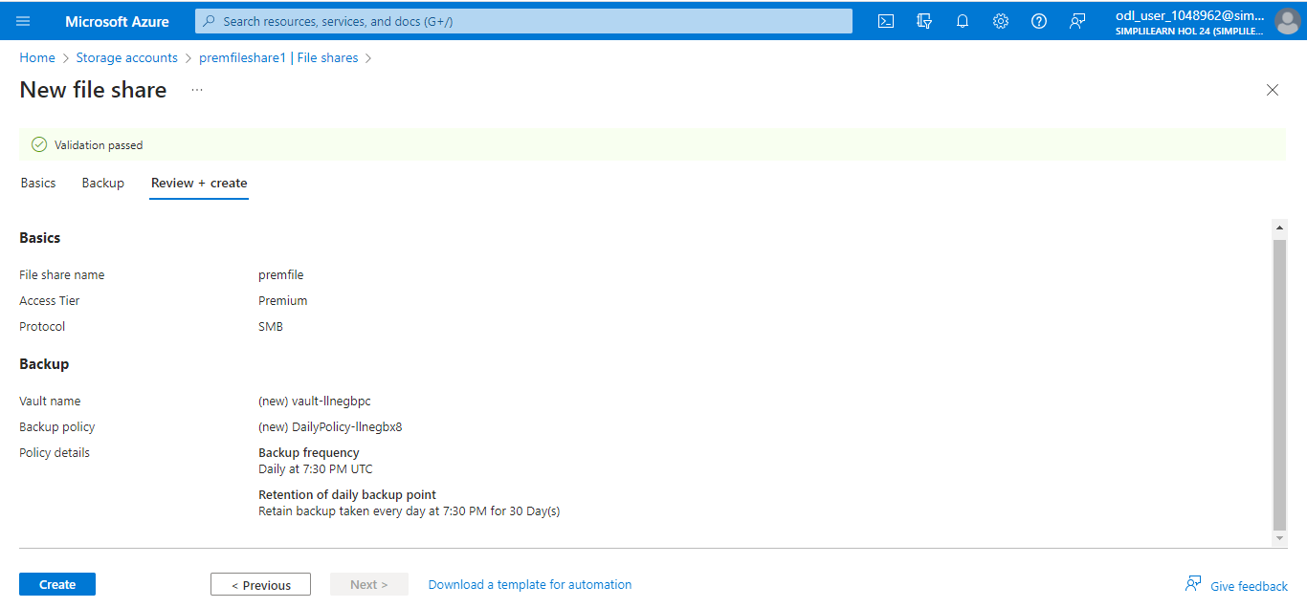

2.11 After file share is created, click on Upload.

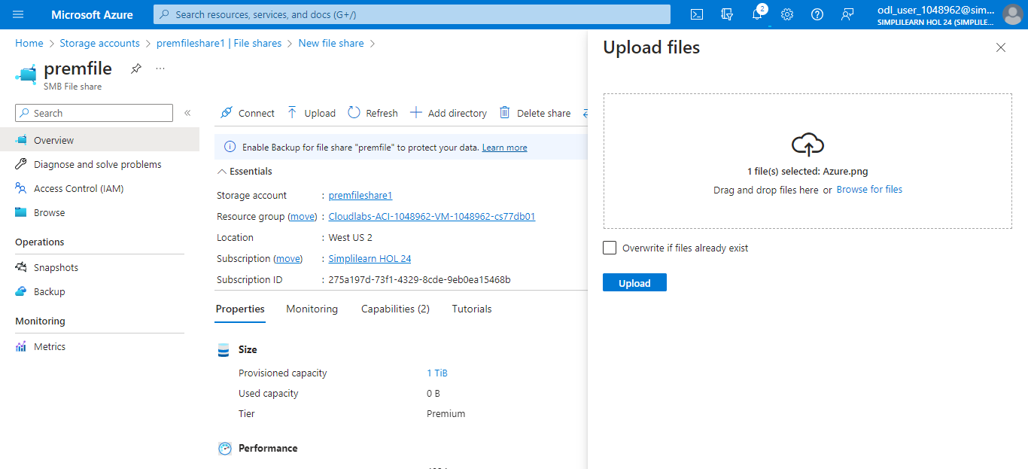

By following these steps, you have successfully created a file share that would function as a network file mount between different Azure or on-premises virtual machines.

